Task 5

Nastaran Tafazoli 10662943

Calculate the heat exchange between the two parallel plates:

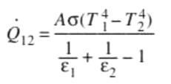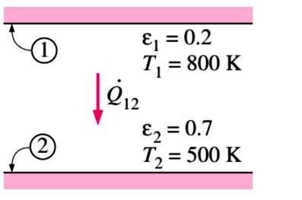

Q̇ = 3625,35 \* A [W]

=

A \*

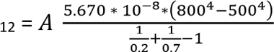

If the two emissivities of the plates are 0.1:

Q̇ = 1035,82 \* A [W]

=

A \*

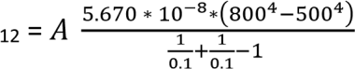

Conclusion:

With the same area and variation of temperature, increasing the emissivity it also increases the heat exchange between the two parallel plates